The Decomposition of Intrahousehold Gender Inequality in Agricultural Technology Adoption after Correcting for Measurement Error

Abstract

Introduction
Women play a key role in farm work where they are responsible for family food security and home production (Meinzen et al., 2010). However, women may have limited access to production resources, information, education, markets, extension services, and other subtle forms of social and cultural inequality” (Quisumbing 1995, Doss, 2001). “In general, there is agreement that gender inequalities and lack of attention to gender in agricultural development contribute to lower productivity, lost income, and higher levels of poverty as well as undernutrition” (Amber, Julia and Anges, 2010).
“Gender and Agriculture, a recent sourcebook produced by the World Bank, FAO and IFAD (2009, p. 2), warns that the “failure to recognize the roles, differences and inequities [between men and women] poses a serious threat to the effectiveness of the agricultural development agenda” Since the 1990s, policymakers and development practitioners have increasingly recognized the vital significance of considering gender factors when implementing, evaluating, and determining the effectiveness of programs in diverse social and economic sectors (Amber, Julia and Anges, 2010).
Gender inequality not only affect technology adoption analyzed by a fair amount of literature, but also may affect the self-reported data. There is no study analyzed whether the gender inequality of technology adoption was caused by inequality of self-reported data, or the true technology inequality. If gender inequality could affect technology adoption as discussed in many studies, is it possible that women have limited information of the household? Although a fair amount of attention has been paid to the determinants of technology adoption in the economic development literature, no attention has been given to understanding how gender inequality affect self-reported data, and how it further affect the gender inequality studies. This study has two folds. In the first section, we discuss gender inequality in self-reported data and the consequences in research. “As
Wossen et al. (2018) and Abay et al. (2023) discussed the
The second contribution we make to the literature is that in gender inequality of technology analysis, literature failed to comprehensively evaluate the gender gap due to the observable differences of explanatory variables across genders, and the unexplained porta
For the second contribution, we analyzes the gender inequality in technology adoption employing the Oaxaca-Blinder decomposition method which allows decomposition of gender gap into the following: 1). The portion caused by observable differences in the factor of production and 2). the group differences in the coefficients, which is the differences in turn to the explanatory variables.

Building upon Amber's (2010) work, gender inequality is characterized as the uneven distribution of opportunities, responsibilities, and benefits among individuals of different genders.

The World Bank, FAO, and IFAD's series of publications (e.g., Quisumbing et al., 2014; )Fortmann, 2009) have highlighted that neglecting to acknowledge the varying roles, disparities, and inequalities between men and women in the agricultural sector poses a significant risk to the success of agricultural development efforts.
Understanding gender inequality in technology adoption is crucial for effective policy formulation in agricultural development. While gender roles and relations have been studied in the context of inequalities in technology adoption, existing research often overlooks the impact of measurement errors in survey data. Such errors can lead to biased understandings of gender inequality in agricultural technology adoption. This study aims to deepen the understanding of the gender inequality in agricultural technology adoption by identifying and correcting non-classical measurement errors that are endogenously related to the sex of the respondent. Leveraging a comprehensive intra-household dataset collected from cassava farmers in Nigeria, combined with DNA fingerprinting data to identify cassava varieties at the household level, we investigate the presence of measurement errors in self-reported agricultural data and their association with the sex of the respondent. Through comparative analysis of responses from husbands and wives within the same households, we not only confirm the existence of measurement errors but also establish their endogenous relationship with gender. After correcting measurement errors, we apply the Oaxaca-Blinder Decomposition method to identify the factors driving gender differences in technology adoption. Furthermore, Monte Carlo simulations are employed to highlight the potential impact of these errors on regression outcomes. This aspect of the study reveals the biases that can arise in research when measurement errors are overlooked or inadequately addressed. A critical aspect of our research is the identification of pervasive misreporting in agricultural surveys. This phenomenon is not just a statistical irregularity but is intricately connected with gender. Our results suggest a systematic relation between misreporting of technology adoption and gender, leading to biased estimation of the gender technology adoption gap. Moreover, this study also underscores the value of data integration. We utilized existing datasets from the IITA data repository, compiled through the Cassava Monitoring Survey in Nigeria, integrating them using a custom-developed data integration warehouse. This approach not only consolidates various data sources but also enhances the robustness of research analysis. By quantifying measurement errors and offering methodological improvements, this paper significantly advances the understanding of gender inequality in agricultural technology adoption, contributing to more nuanced and accurate policy formulation in the agricultural sector.

Introduction
Government, industry, and non-profit leaders in agriculture and natural resources have a growing interest in addressing problems of inequity in agricultural, food, and environmental systems. While substantial efforts have been made to address gender gaps in technology adoption within the agricultural sector, the existing literature often overlooks a critical aspect—measurement errors in survey data. These errors can distort our understanding of gender disparities in agricultural technology adoption, leading to inadequate policy formulation.

This study aims to address this gap in the literature by examining the presence of measurement errors in self-reported agricultural data and their association with the sex of the respondent. By leveraging a comprehensive intra-household dataset from cassava farmers in Nigeria, combined with DNA fingerprinting data to identify cassava varieties at the household level, we not only identify the presence of measurement errors but also establish their endogenous relationship with gender.

Data
This study is based on the intra-household cassava monitoring survey (CMS) in Nigeria. Cassava (Manihot esculenta) stands as a vital staple crop, serving as the primary source of calories for approximately 500 million individuals worldwide. Its capacity to thrive with minimal external inputs, particularly in the face of environmental stressors such as drought (EL-Sharkawy, 2003), makes it an essential component of food security and resilience strategies (Montagnac, Davis, and Tanumihardjo, 2009). In Nigeria, cassava cultivation is predominantly carried out by smallholder farmers, both men and women, typically managing land parcels ranging from 1 to 5 hectares (Joyce Ahmadu and P. O. Idisi, 2014). It occupies a pivotal role in the country's food economy, ranking as the primary source of carbohydrates after maize and rice (Udensi E Udensi et al., 2011). Given its paramount significance, extensive efforts have been devoted to enhancing cassava production through global, regional, and national crop improvement initiatives, leading to the development and adoption of new cassava varieties (Tahirou Abdoulaye et al., 2014).

The analysis conducted herein is based on a subset of data collected through the Cassava Monitoring Survey in Nigeria. This survey underwent rigorous ethical review concerning human subject participation (IRB) and was subsequently published by the International Institute of Tropical Agriculture (IITA) (Wossen et al., 2017). The dataset encompasses 16 states, each contributing at least 80% of the total cassava production. These states constitute the enumeration areas (EAs) distributed across four regions: Southwest, Southeast, South-South, and North.
To create a representative sample, sample frames were established for all households engaged in cassava cultivation in the targeted states. Subsequently, a minimum of 50 cassava-growing households were selected per state, resulting in a sample size of 125 EAs. Within each enumeration area, interviews were conducted with five household heads and two spouses, amounting to 625 households in each region. Consequently, a total of 2,500 randomly selected cassava-growing households were interviewed across the major cassava-growing states in Nigeria's four geopolitical regions. These states collectively account for over 80% of the annual total cassava production.

From the overall survey dataset, interviews were conducted with both the designated household head and an additional household member. This process yielded a subset of 758 households. However, for inclusion in this analysis, households had to meet specific criteria: the recorded relationship to the household head had to be self or spouse, marital status had to be married, and both members needed to report living with their spouse. As a result of these criteria, 29 households were excluded, leaving a final sample of 729 households, consisting of 1,458 men and women.
It is important to note that the terminology used intentionally employs "husband" and "wife" rather than "household head" and "spouse." Within this analysis, there are 13 instances of women serving as household heads and three cases where men are identified as spouses. Among these responses, one household's wife responded as the household head, and the husband responded as the spouse. In the remaining 12 households, both respondents identified themselves as the household head, while two households featured both participants identifying as spouses.
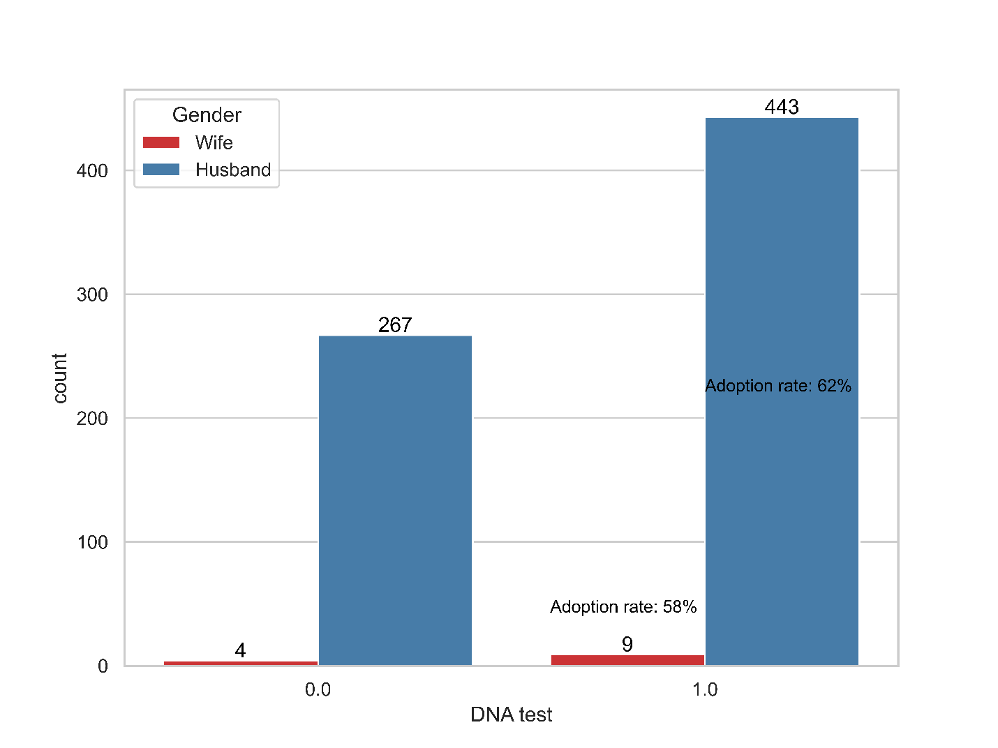

Methodology
In the first section, we will discuss the problem of measurement error in self-reported data and explicitly discuss it’s consequence in regression analysis.
Let Y$Y_{i}$ be the outcome variable of interest, that is, adoption of improved cassava varieties (ICV). Assuming that the probability of adopting ICV is a function of resources and social-economic variables, we have the following relationship:

The observable outcomes of the binary choice are represented by binary indicator variable

“The Blinder-Oaxaca decomposition is a statistical method that decomposes differences in mean outcomes across two groups into a part that is due to group differences in the levels of explanatory variables and a part that is due to differential magnitudes of regression coefficients.”

Results

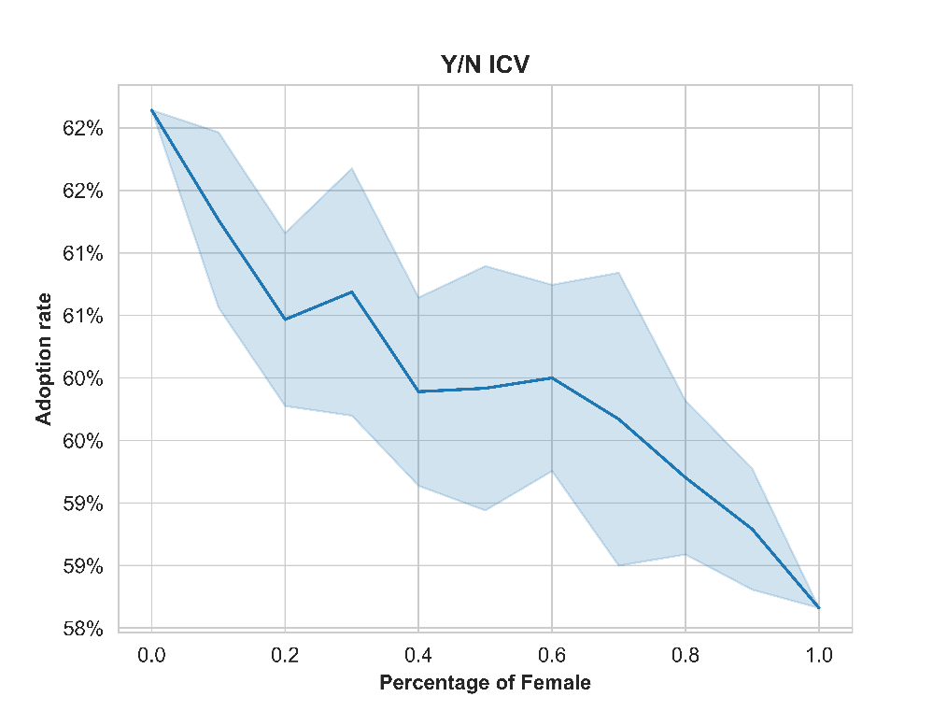

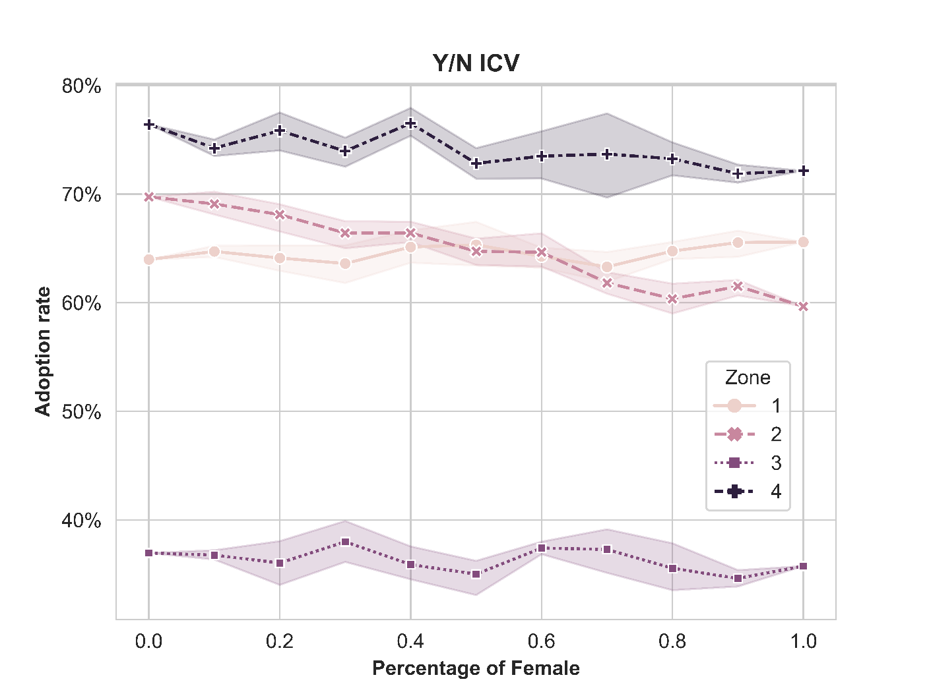
Note: 5 iterations of each percentage of female.
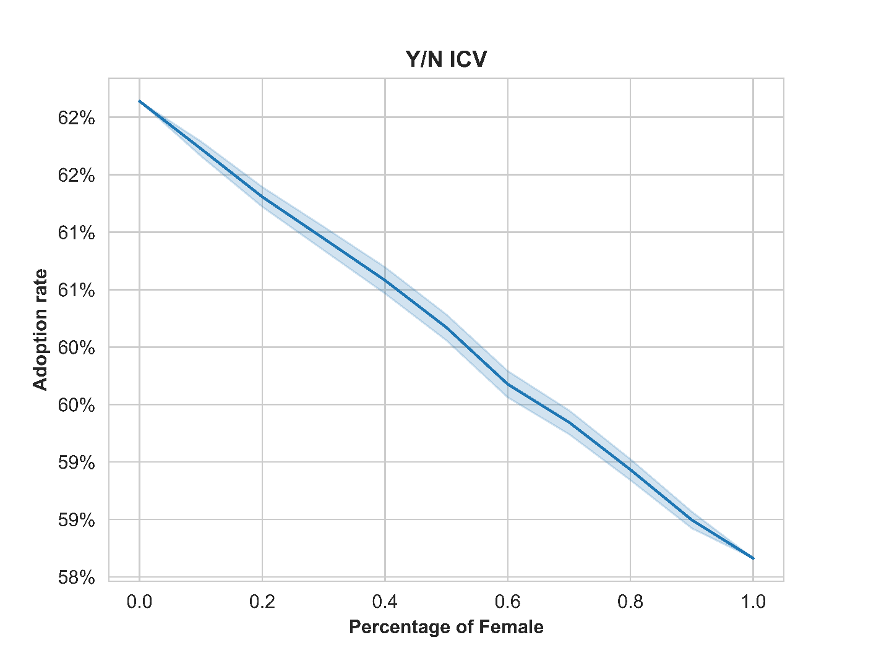
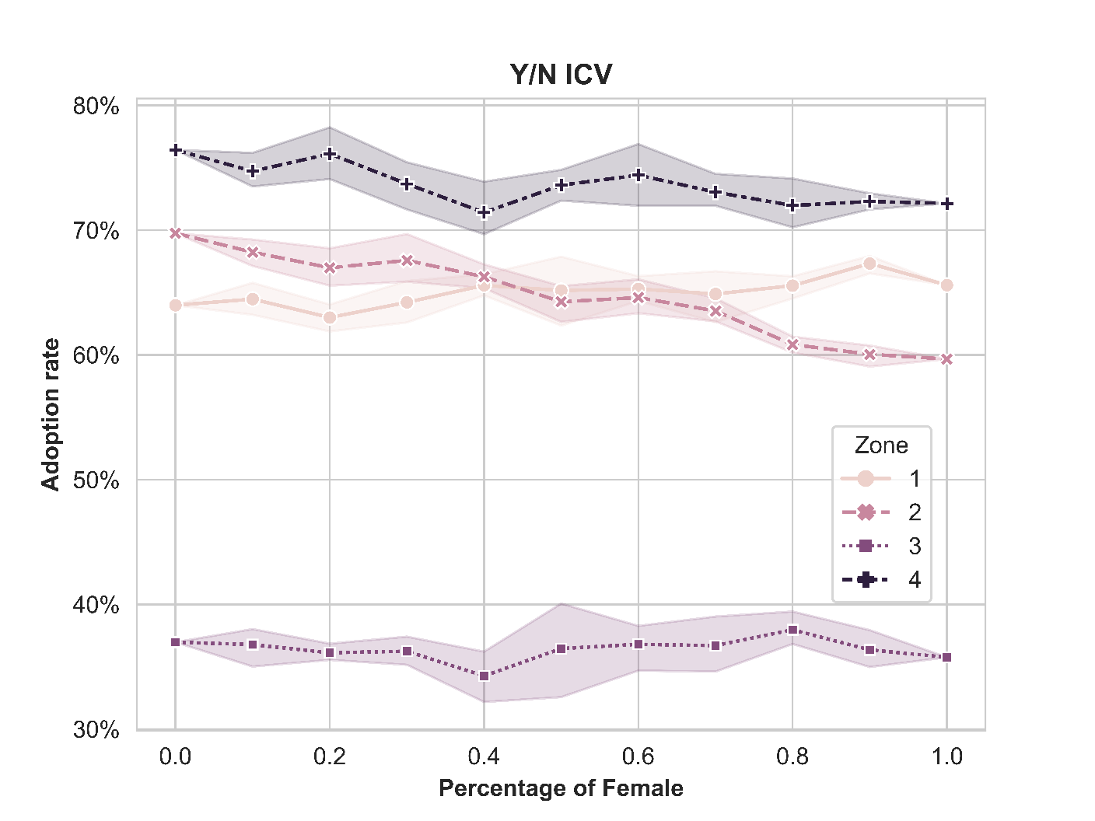
Note: 500 iterations of each percentage of female.

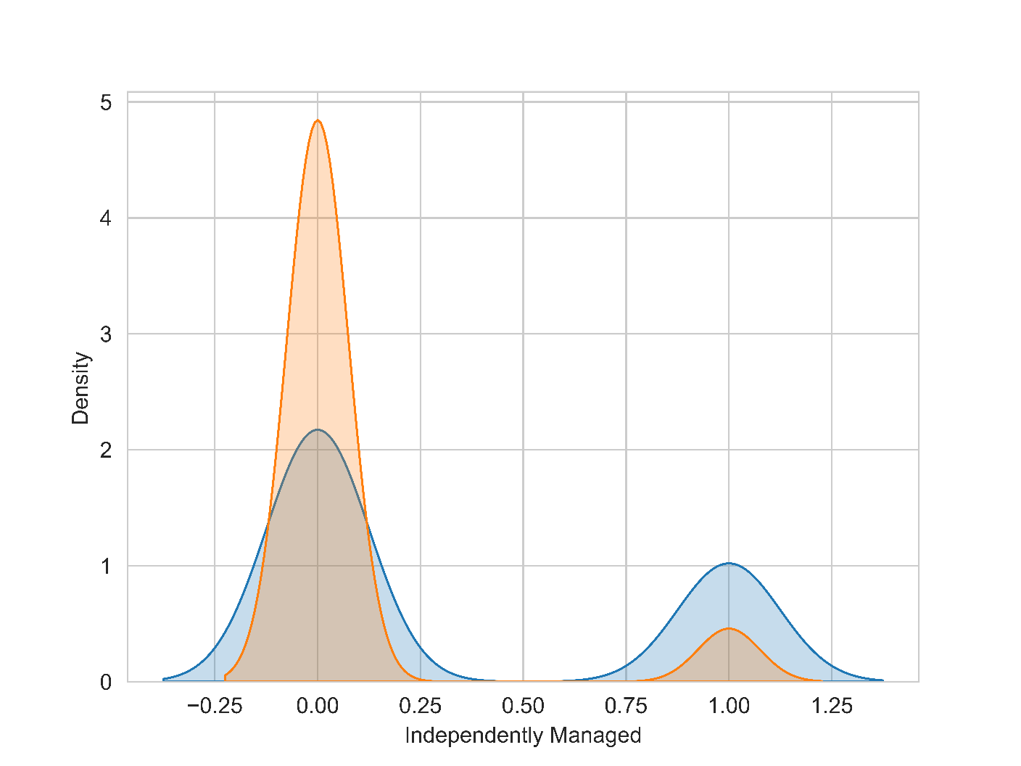
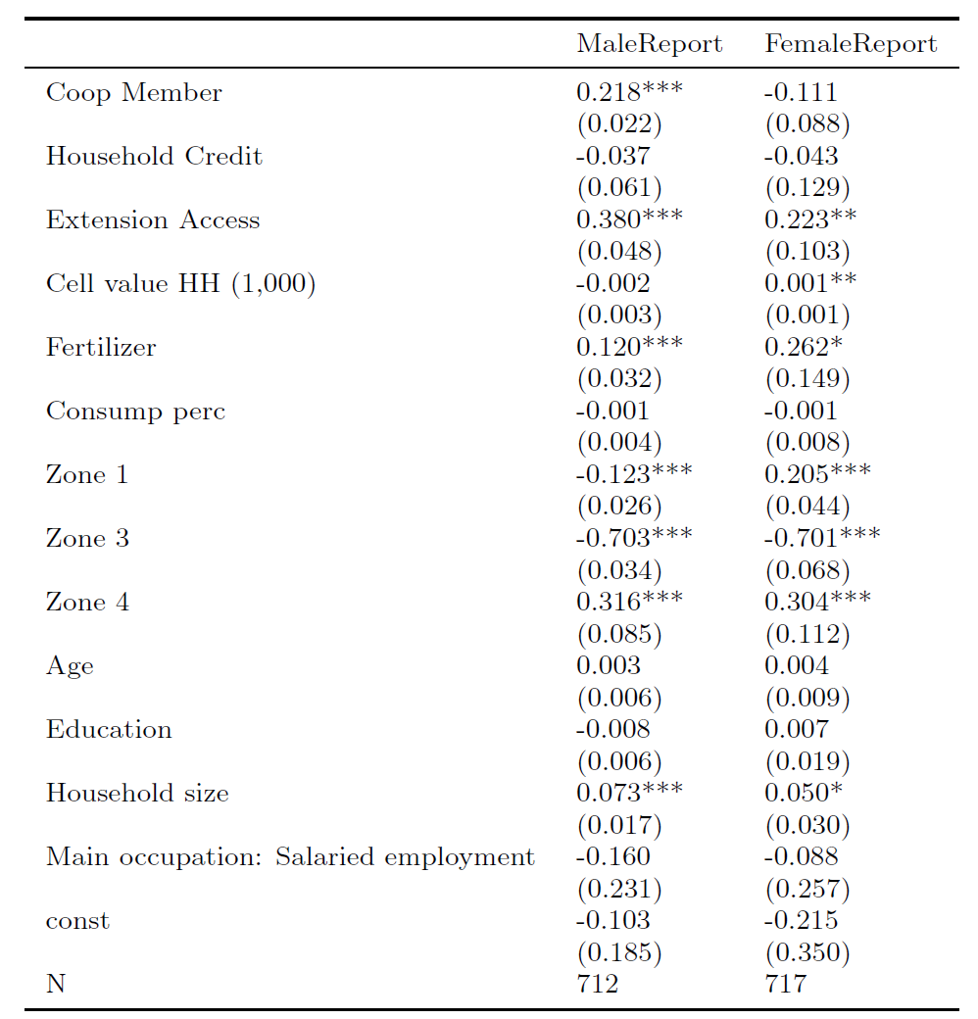
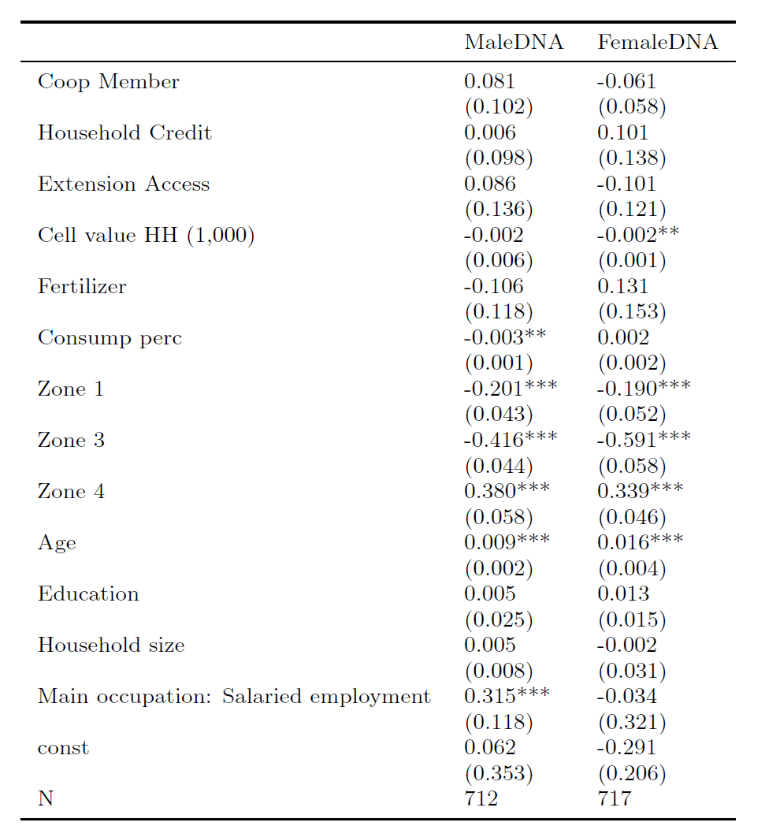
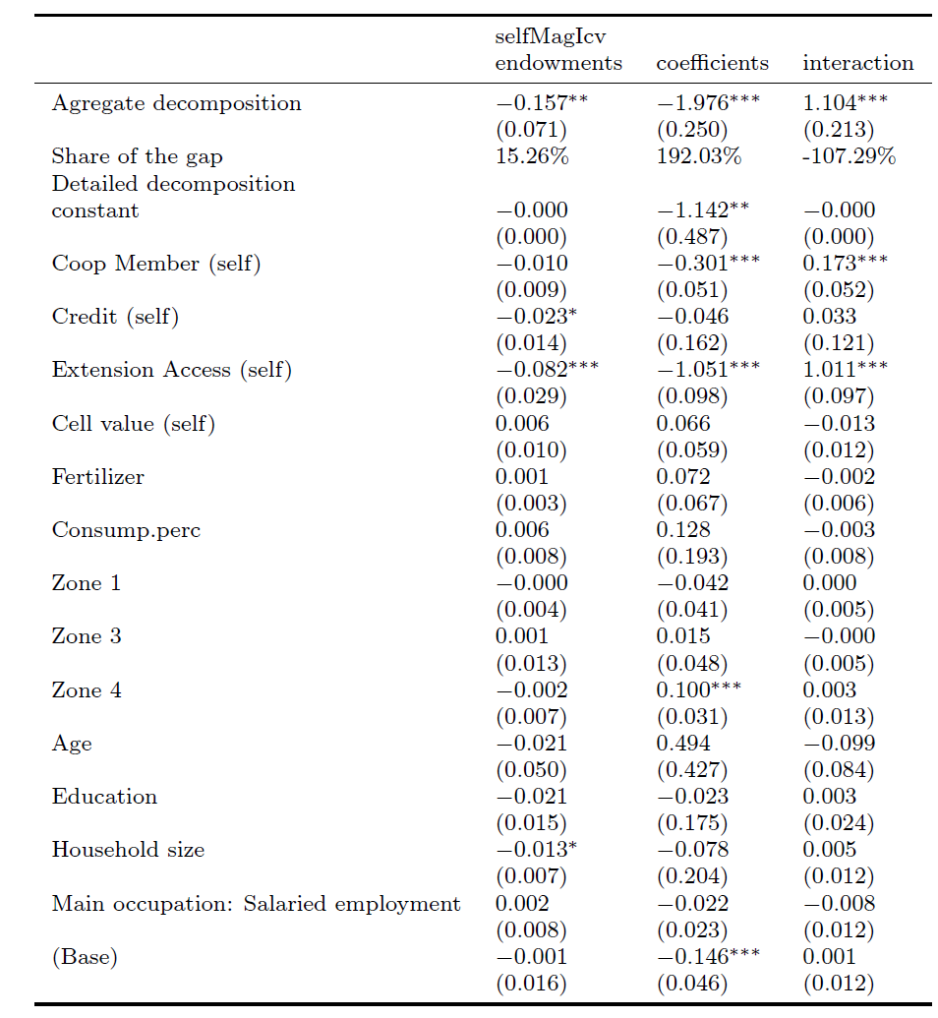

References
IFAD (International Fund for Agricultural Development). 2003. Mainstreaming a gender perspective in IFAD’s operations: Plan of action 2003–2006. Rome: IFAD.

